Beta Nu Bytes

The Delta Kappa Gamma Society International- Eta State, North Carolina
Beta Nu Chapter Forsyth County Region IX

Vol. 5, No. 15 September 2016- January 2017


In an effort to get to know our Beta Nu sisters better, we’d like to feature a few members in each newsletter. Please take a few moments to share a little about yourself with the survey found at the link below.
https://goo.gl/forms/Jd7BvNcajZwudFFZ2
Member
Spotlight…


February 4th:
“Making Daily Movement and Healthy Eating a Priority”
William Ellis Middle
Advance, North Carolina
9:30 a.m.

Put on your tennis shoes and come get your heart pumping with a fun focus on fitness. Bring canned foods to use as weights during our Zumba session. These will be collected and donated to the Second Harvest Food Bank after our meeting. Don’t forget any monetary donations you would like to give to the World Fellowship Fund as those will be collected as well.
April 8th:
Joint Chapter Luncheon
New Philadelphia Moravian Church, Country Club Road
10:00 a.m.

We need your ideas!

As chapter leaders gather to plan for future events, they would love to have input from each of you. Click HERE to submit any ideas you have for future events, outings and speakers.

We know you know great people. It’s that time of year to nominate new members, and applications need to be in soon! Please email Susan Carter-Hope your nominations this week.

scarterhope1952@gmail.com

Professional Development

Are you looking for professional development support? Check out the Lucile Cornetet Award found HERE on the DKG Educational Foundation website.
Interested in returning to school and continuing your education? Take a look at available scholarships listed on the DKG Eta State forms page HERE.
** Applications are due February 1, 2017.

President’s Corner

Greetings, Beta Nu Sisters!

T. S. Eliot stated, “Last year’s words belong to last year’s language. And next year’s words await another voice.”

As we welcome 2017, I hope we are ready to embrace the opportunities that await us in the new year. May we adjust our “perspectacles” so that we see things that have never been, look for the positive, and support each other as members of humanity through compassion, truth, humility, and grace. The 2017 year promises to be a year filled with whatever you choose for it to be. Whatever your choice, remember the words of Bob Perks in Chicken Soup for the Grieving Soul, "I wish you enough sun to keep your attitude bright. I wish you enough rain to appreciate the sun more. I wish you enough happiness to keep your spirit alive. I wish you enough pain so that the smallest joys in life appear much bigger. I wish you enough gain to satisfy your wanting. I wish you enough loss to appreciate all that you possess. I wish enough ‘Hello's’ to get you through the final ‘Good-bye.’"
Welcome 2017. We are ready to embrace all blessings no matter how small!

Leigh

Please remember to complete the website permission form and submit/return it ASAP. Click HERE for a copy.

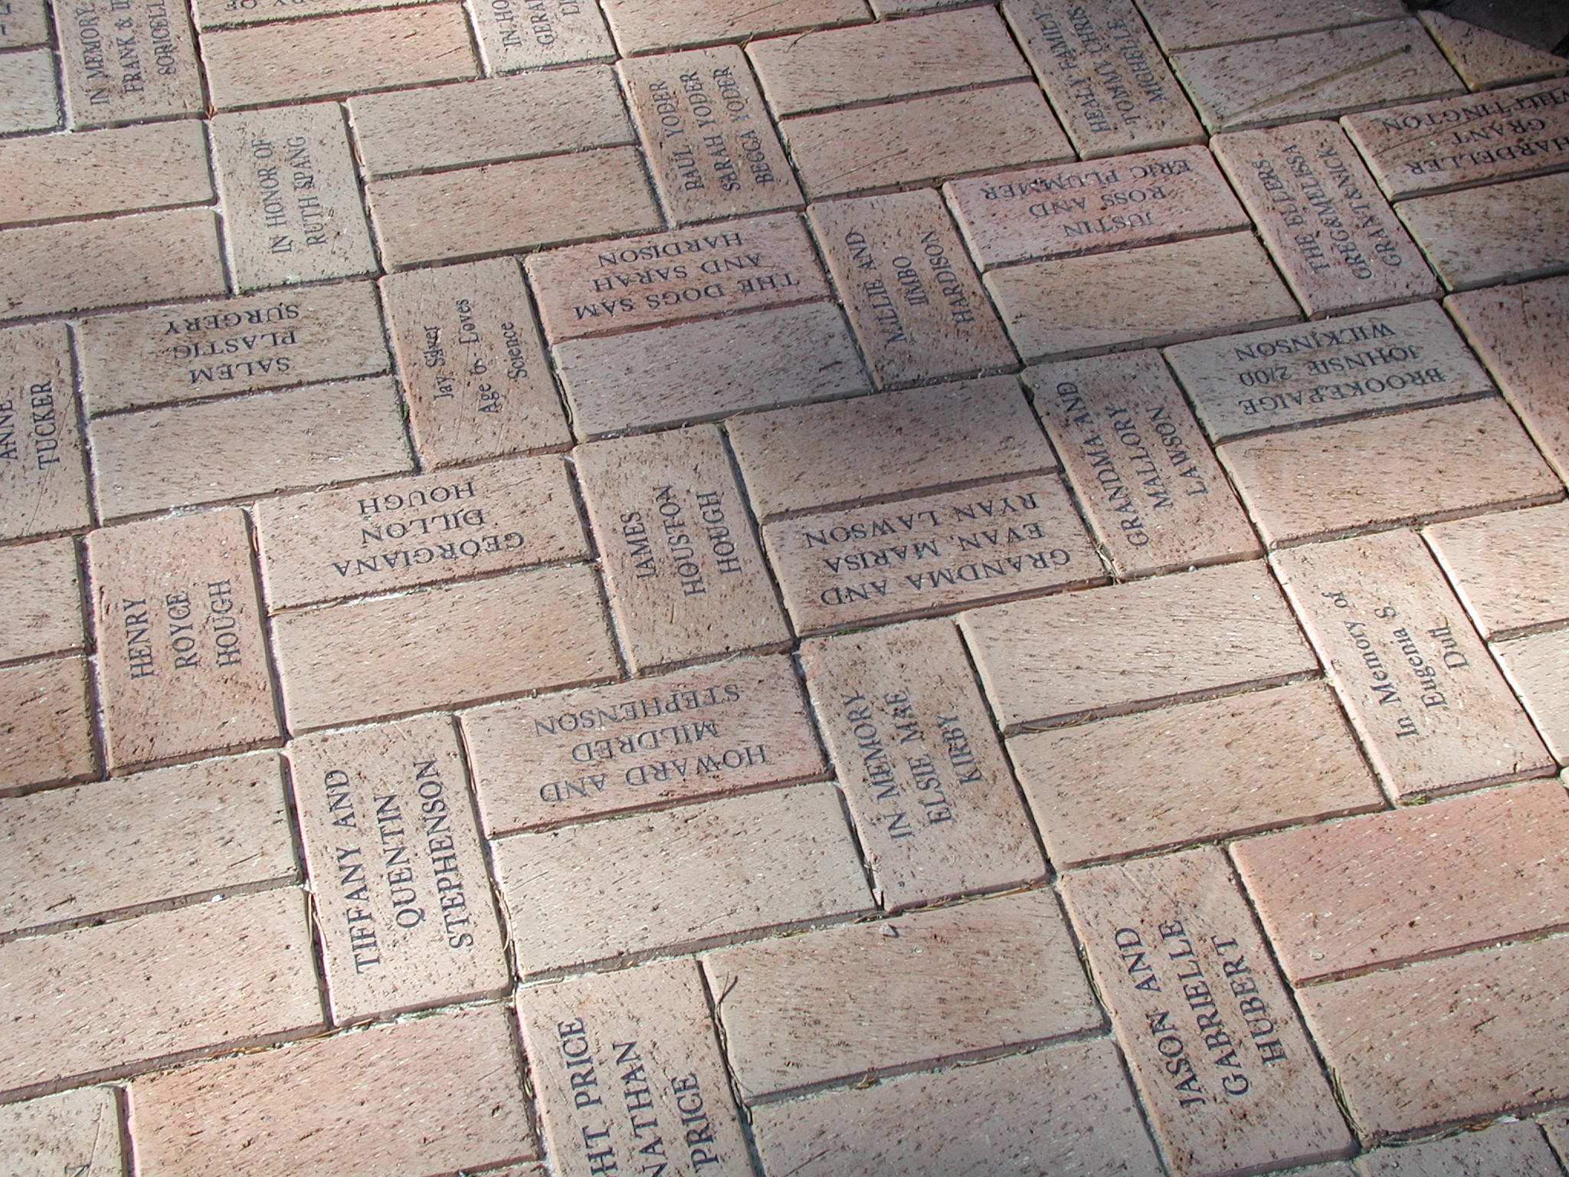
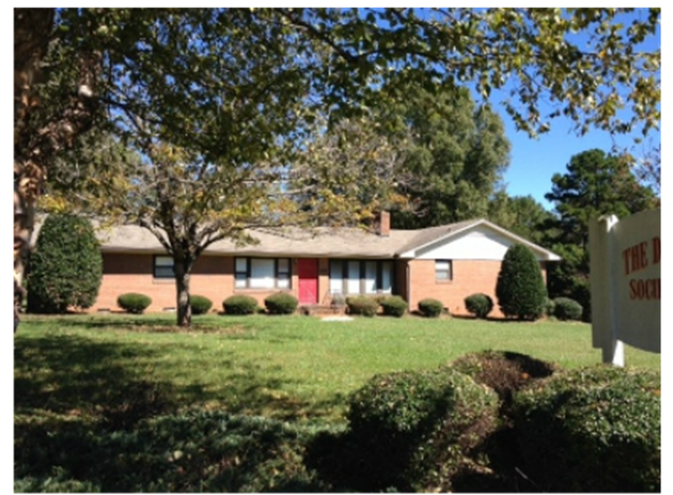
Beta Nu Helps “Pave the Way”

One of our Beta Nu members made an anonymous donation to the Eta State Headquarters “Pave the Way” campaign in honor of our chapter. A brick paver was purchased for the walkway to the headquarters house in Asheboro, NC, and it will be engraved with our chapter name. Many thanks for this thoughtful gesture!
This campaign is ongoing, so any members who would like to purchase a brick to honor or celebrate someone special may still do so. Click the brick below for more information.


Memories from Weathervane Winery

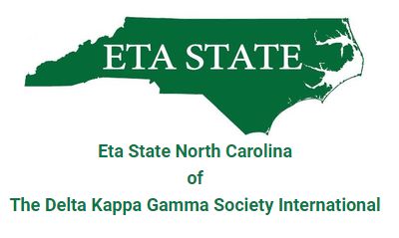
Updates from Eta State…

- The new Eta State website has been unveiled. Check it out at http://www.ncdkg.org/
- Plans for the 2017 Eta State NC Convention are well underway and hotel registration is now open. The Hilton Wilmington Riverside Hotel will be the site of the convention April 28-30, 2017. Deadline for the group rate is March 27, 2017, but for the last few years, the convention hotel has filled before the deadline, so book early! HOTEL REGISTRATION LINK
- Upcoming Convention Dates:

April 28 - 30, 2017 — Eta State NC Convention, Hilton Wilmington Riverside, Wilmington, NC (Region IV)
June 23 - 25, 2017 — Eta State NC Leadership Development Seminar, Caraway Conference Center, Asheboro, NC July 19 - 22, 2017 — Southeast Regional Conference, Sheraton Myrtle Beach Convention Center, Myrtle Beach, SC
April 27 - 29, 2018 — Eta State NC Convention, Charlotte University Hilton, Charlotte, NC (Region VI)
July 16 - 20, 2018 — DKG International Convention, JW Marriott, Austin, TX
Celebrate our Sisters!

January
- 18th- Zinda Coninger & Jane Timmerman
- 21st- Annette Mann
- 26th- Sheryl Long
- 27th- Heather Barksdale

February
- 10th- Marty Tedrow
- 11th- Belinda Beard
- 17th- Kay Chesson
- 18th- Linda Cappel
- 20th- Susan Edge
- 21st- Nada Hill

March
- 14th- Donna Cannon
- 20th- Charlotte Brown
- 21st- Nancy Hoover
- 24th- Sarah Huddleston
- 27th- Jennifer Murphy

April
- 3rd- Kirby Carespodi & Sandra Shugart
- 4th- Carol Harris
- 16th- Susan Carswell & Belinda Ellington
- 29th- Carolyn McKinney



International Website:
https://www.dkg.org

